Circulatory & Respiratory Systems – Extended Response

- Emphysema is a disease which affects the alveoli and may be caused by long-term exposure to tobacco smoke. Explain how this disease affects the efficiency of the respiratory system and any of the symptoms the person is likely to experience?
Emphysema is a disease usually caused by long-term exposure to irritating particles in the air taken into the lungs. No one can avoid inhaling particles, but some people are exposed to excessively high levels.
The irritating particles cause damage to the alveoli and destroy the walls between alveoli. The inner walls of the alveoli rupture. This leaves the lungs less able to absorb oxygen into the bloodstream and remove carbon dioxide from the blood. This results in a higher level of carbon dioxide and a lower level of oxygen in the body. There’s also a decreased amount of oxygen going to peripheral tissue. They lose their elasticity, are often replaced with fibrous tissue, and may break down, reducing the internal surface area of the lung and, in turn, the amount of oxygen that reaches the bloodstream. Lung tissue also loses its resilience, which prevents it from stretching and contracting properly. When the lungs lack resilience, they cannot fully push out air. Instead, some air remains trapped in the air sacs. When exhaling, the old air containing the CO₂ gets stuck in the lungs. Because of the loss of elasticity and resilience of the lung tissue, the lungs are constantly inflated and exhaling no longer passively occurs but requires voluntary effort. Thus, the emphysema sufferer has 2 problems:
- Inadequate surface area for gas exchange.
- Difficulty in ventilating the lungs.
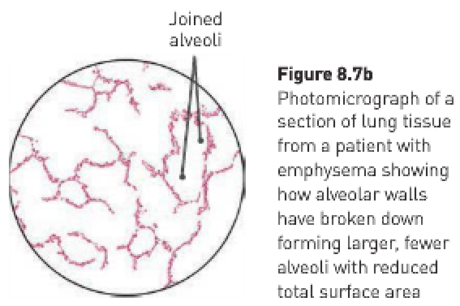
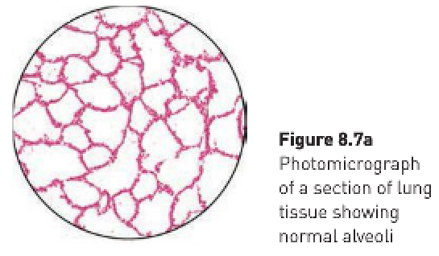

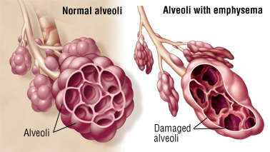
The main symptom of emphysema is shortness of breath, which usually begins gradually. Initially, the sufferer has difficulty catching his/her breath during activity. Over time, he/she may feel breathless after just taking a few steps, or when sitting or lying down. Other symptoms include:
- Wheezing.
- Weight loss.
- Loss of muscle.
- A barrel chest due to the over-inflation of the lungs.
- Lips and fingernails turn blue when the body is exerted (due to increased CO₂ in the blood).
- Not mentally alert (due to lack of oxygen to the brain).

- Single-celled bacterium do not require a circulatory system, however large multicellular animals do. Explain why this is so; and how the circulatory system delivers oxygen and nutrients to and removes waste from the cells of the human body.
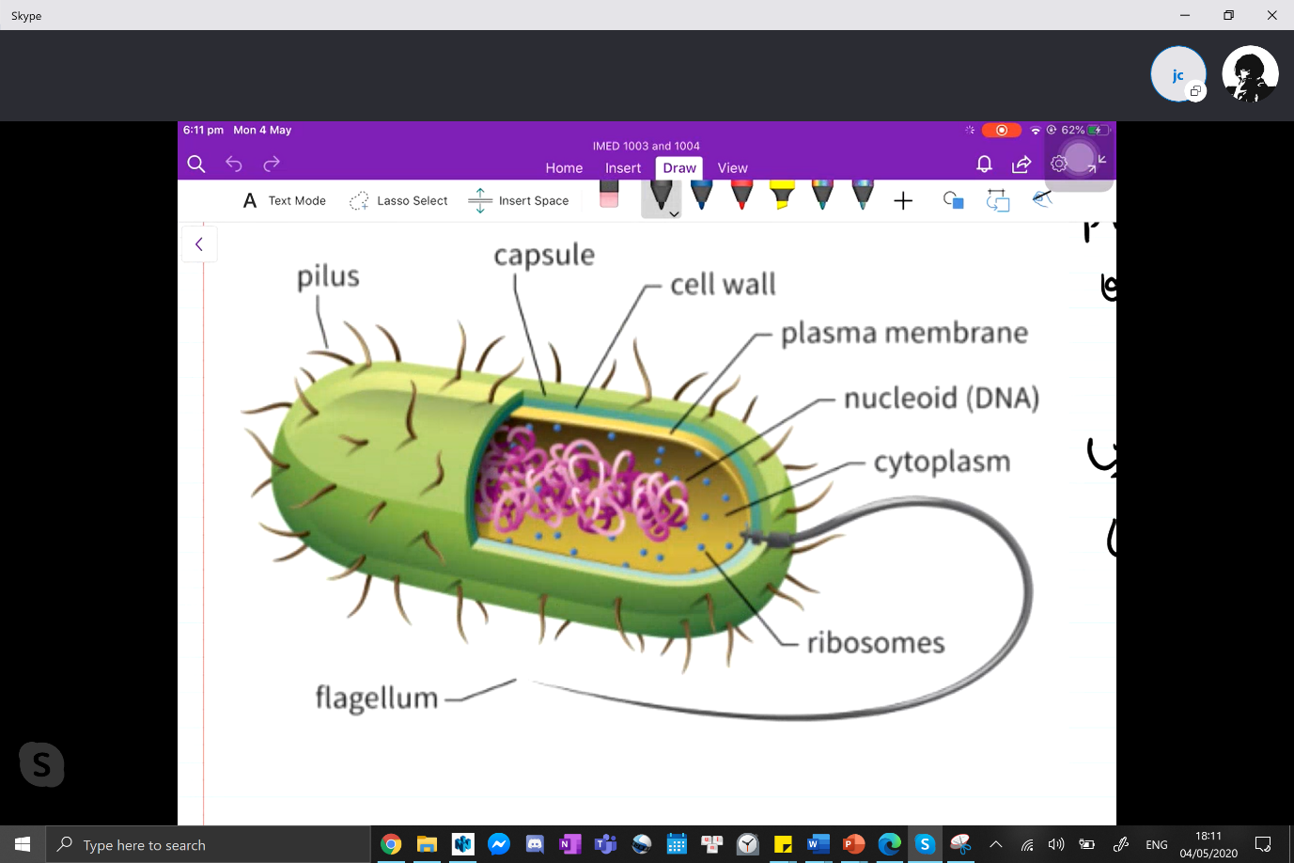
A single bacterium consists of an external layer of polysaccharides, a cell wall (plasma membrane) and the cytoplasm which contains the ribosomes and nucleoid. A large, multicellular organism has trillions of cells with a plasma membrane and a cytoplasm which contains many different organelles as well as the nucleus which contains complex DNA strands.
The fact that the large multicellular organism’s cells are much more complex and that there are much more of them contributes to the need for a circulatory system to supply nutrients and remove wastes, and the simplicity and much small number of unicellular bacteria contribute to them not needing a circulatory system to supply nutrients and remove wastes.
Larger, more complex multicellular organisms can’t obtain oxygen and nutrients or dispose of wastes simply by diffusion to the external environment. This would be too slow and inefficient.

The circulatory system carries oxygen and nutrients to the body cells in the blood plasma of the circulatory system. They leave the capillaries, diffuse into the tissue fluid and turn into the cells.
Components of plasma:
- Water (90%).
- Nutrients.
- Gases.
- Wastes.
- Hormones.
- Proteins.
- Ions.

Oxygen isn’t very soluble in water, so only approximately 3% of oxygen is carried in solution in the blood plasma while the other 97% is carried in combination with haemoglobin molecules, which are found only in erythrocytes. Haemoglobin is able to combine with oxygen to form a compound called oxyhaemoglobin. Oxyhaemoglobin can easily break down to release the oxygen.
The presence of haemoglobin in the erythrocytes increases the oxygen-carrying capacity of the blood by 60-70 times. Oxygen combines with haemoglobin in situations where oxygen concentration is relatively high. This occurs in the capillaries in the lungs where oxygen diffuses into the blood from the air in the alveoli. Oxyhaemoglobin breaks down to haemoglobin and oxygen in situations where the concentration of oxygen is relatively low. As the cells of the body are continually using oxygen, the tissue fluid around the cells has a relatively low oxygen concentration. While flowing through the capillaries between the body cells, the erythrocytes give up their oxygen which diffuses into the tissue fluid and then into the cells.
Erythrocytes are well-suited to their function of oxygen transport because they:
- Contain haemoglobin, which is able to combine with oxygen.
- Have no nucleus, so there’s more room for haemoglobin molecules.
- Are shaped like biconcave discs – The biconcave centre increases the surface area for oxygen exchange and the thicker edges gives a large volume that allows room for the haemoglobin molecules.

The transport of oxygen and carbon dioxide:
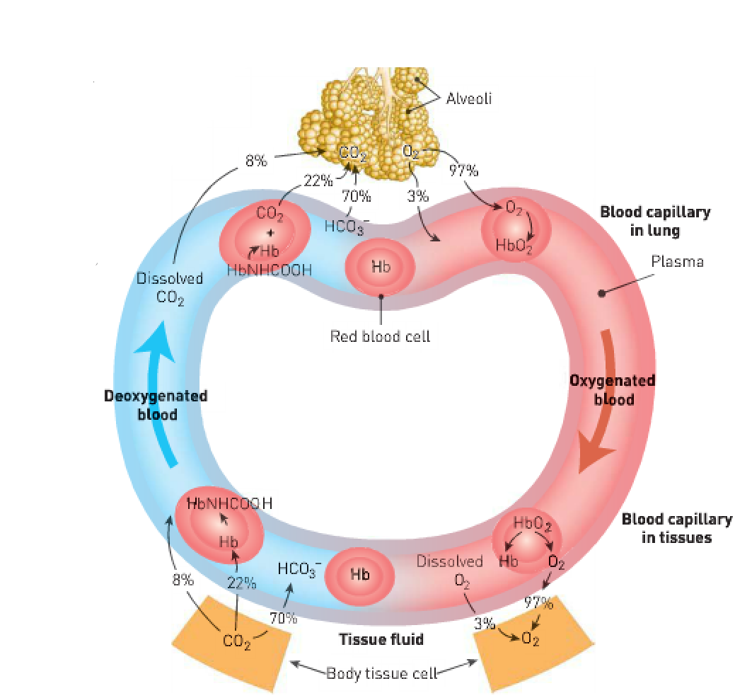
Nutrients and wastes (excluding carbon dioxide) are transported dissolved in the blood plasma. All cells excrete waste into the blood. Inorganic nutrients are transported as ions. Some of the important ions dissolved in the blood plasma are sodium ions, calcium ions, potassium ions, chlorine ions and iodide ions. Organic nutrients dissolved in the plasma include glucose, vitamins, amino acids, fatty acids, and glycerol.
Metabolic wastes are substances produced by cells that can’t be used and would be harmful if allowed to accumulate. The most important organic wastes that are transported in solution in the blood plasma are urea, creatinine, and uric acid.

- Compare the circulatory and lymphatic system of the body. In your response, refer specifically to the contents of the fluid that is transported in each system and the function of this fluid in each system.
 | Circulatory system | Lymphatic system
Definition | The body’s main internal transport system. | The body’s transporter of lymph throughout the body.
Function | Transports oxygen and nutrients to cells, transports carbon dioxide and other waste products away from cells, transports hormones, maintains the pH of body fluids, distributes heat and maintains body temperature, maintains water content and ion concentration of body fluids, protects against disease-causing micro-organisms and clots when vessels are damaged, thus preventing blood loss. | Collects some of the fluid that escapes from blood capillaries and returns it to the circulatory system and plays an important part in the body’s internal defence against disease-causing micro-organisms.
Consists of | Blood (haemoglobin, plasma, thrombocytes, erythrocytes and leucocytes), blood vessels (arteries, veins and capillaries) and the heart. | A network of lymph capillaries joined to larger lymph vessels and lymph nodes which are located along the length of some lymph vessels.
Transportation of fluids | Moves through the heart, blood vessels and the lungs. | Moves through lymphatic vessels.
Carrying of materials | Carries nutrients and waste products to and from organs. | Carries lymph, lymphocytes, macrophages, and plasma cells.
Function in immune response | Leukocytes can remove dead or injured cells and invading micro-organisms. Blood clotting prevents the entry of infecting micro-organisms. | Lymph entering the lymph nodes contains cell debris, foreign particles and micro-organisms that have penetrated the body’s external defences. Macrophages destroy larger particles trapped in the meshwork of fibres as the lymph flows through the spaces in the nodes. When infections occur, the formation of lymphocytes increases.

Transportation of fluids (blood) – circulatory system:
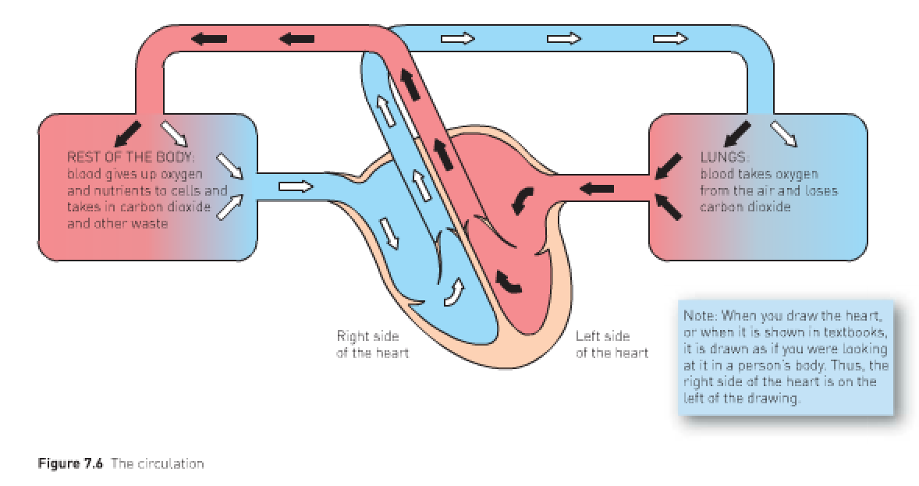

Transportation of fluids (lymph) – lymphatic system:
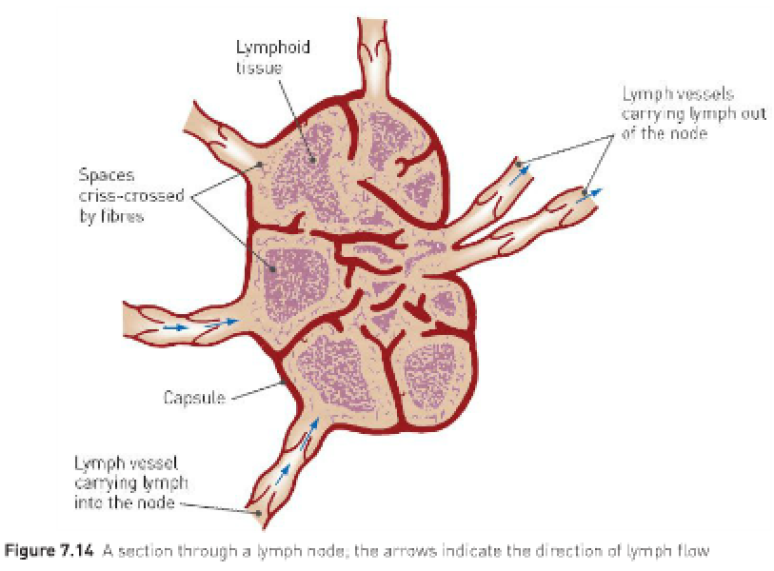

- Explain why someone with an infected toe may experience a lump in his or her groin.
You have an abundance of lymph nodes around the armpit areas, the groin area, and the digestive tract. This is designed to protect against infection if an infection enters via the arms, legs or digestive tract. If you’re infected, these areas become swollen because the lymphocytes inside are multiplying to try to neutralise the threat.
When infections occur, the formation of lymphocytes increases, and the lymph nodes become swollen and sore. For example, an infected finger may result in swelling and tenderness in the armpit, where there are a large number of lymph nodes.
Having swollen lymph nodes usually means your immune system is fighting an infection in the swollen area. For example, if you have a sore throat from a virus, you may get swollen neck lymph nodes. An infection on your leg can cause swollen glands in the groin.
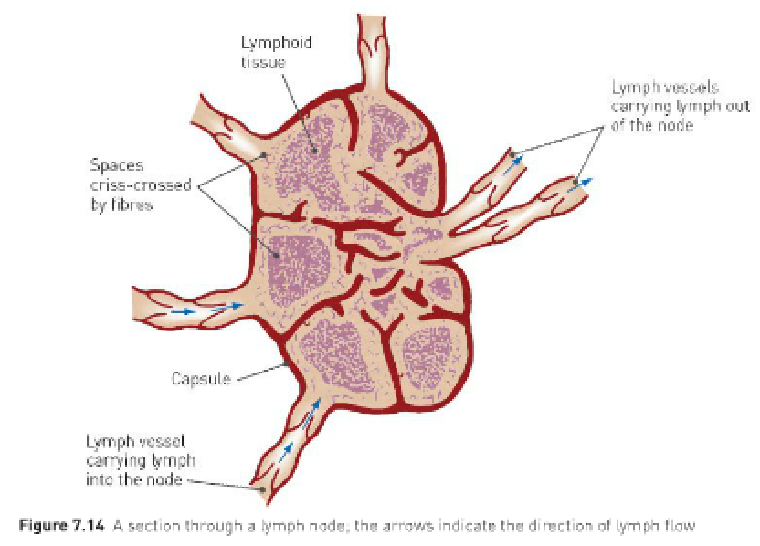
Large phagocytic cells called macrophages destroy larger particles e.g., bacteria which are trapped in a meshwork of fibres as lymph flows through the spaces in the nodes.
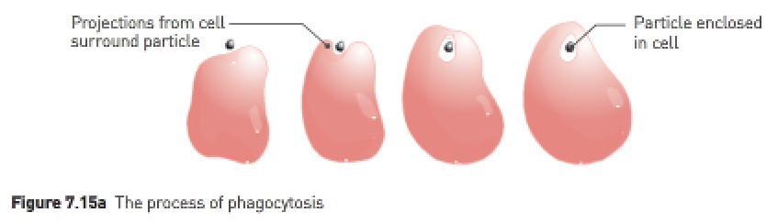

- The respiratory surface in the lungs is designed to maximise gas exchange. Identify and explain five (5) features of the lung’s respiratory surface that allow for maximum gas exchange.
- Blood flows constantly through the capillaries. As the blood flowing through the capillaries around each alveolus picks up oxygen and loses carbon dioxide, it is replaced by more blood pumped into the capillaries. This ‘new’ blood is low in oxygen and high in carbon dioxide so that the concentration gradient is maintained.

Exchange of gases:
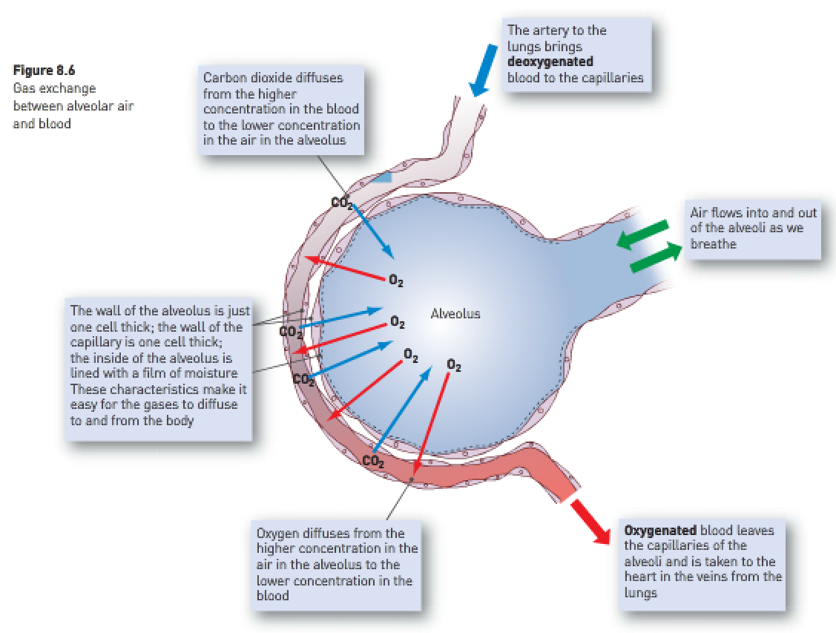
- The alveolus is thin-walled. The alveoli are just one cell in thickness, which allows the gas exchange of respiration to take place rapidly.
- The alveoli’s inner surface is kept moist, it has a rich supply of blood and it has a large surface area for gas exchange. Moisture enables diffusion because gases can only move into and out of blood when dissolved in fluid.
- The alveoli’s location deep in the body minimises evaporation of fluid off their surfaces. This serves to maximally maintain the moist inner surface of the alveoli for gas exchange.
- Constant airflow keeps the necessary diffusion gradients for oxygen and carbon dioxide movement. The constant aeration of the lungs ensures that a high level of oxygen is maintained in the alveoli and the constant flow of blood in the capillaries which surround the alveoli, removing oxygen, ensures that the concentration gradients remain steep. There’s a large difference maintained between the concentration of oxygen in the alveoli and in the blood.

Constant aeration of the lungs:
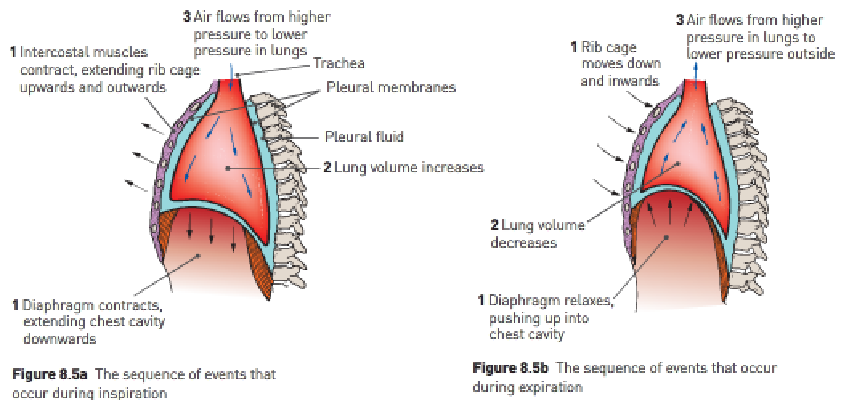

- Describe four (4) key structural and functional features of arteries and describe four (4) key structural and functional features of veins.
Feature: | Artery: | Vein:
Comparative thickness of the wall | Have thick, muscular walls. | Have thin walls with little muscle.
Function | Carries blood away from the heart. | Carries blood towards the heart.
Presence of valves | Has no valves. | Has valves which prevent backflow
Elasticity | Very elastic | Less elastic
Blood pressure | Has a blood pressure that increases as the ventricles contract and decreases as the ventricles relax | Has a constant, relatively low blood pressure.

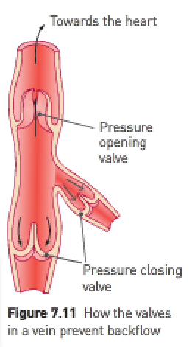
Arteries are the blood vessels that carry blood away from the heart. The walls of an artery contain smooth muscle and elastic fibres. When the ventricles contract and push blood into the arteries, the walls of the arteries stretch to accommodate the extra blood. When the ventricles relax, the elastic artery walls recoil. This elastic recoil keeps the blood moving and maintains the pressure. Hence, artery walls are thick, muscular, and elastic in order to accommodate for the significant pressure. It’s because of the significant pressure that valves aren’t necessary since no backflow occurs.
Veins carry blood towards the heart. Veins don’t have muscular walls and aren’t able to change their diameter in the way that arteries do. Blood pressure in the veins is relatively low because the blood loses most of its pressure as it flows through the tiny capillaries. The pressure in the veins is constant so the walls don’t have to be elastic. Because of the low blood pressure, many veins have valves to prevent the blood from flowing backwards.

- Outline the pathway taken by a red blood cell through the heart. Start at the point where the blood returns to the heart via the vena cava and finish where the blood leaves the heart via the aorta. Include in your answer the events that occur along the pathway.
- The deoxygenated red blood cell enters the inferior and superior vena cava.
- From the vena cava, it enters the right atrium.
- The red blood cell is contracted through the semilunar valve.
- The red blood cell then enters the right ventricle.
- The red blood cell then moves to the pulmonary artery.
- From the pulmonary artery, it goes to the lungs.
- The oxygenated red blood cell enters the pulmonary vein.
- It then enters the left atrium.
- It’s then contracted through the mitral valve.
- It then moves to the left ventricle.
- The red blood cell is then contracted through the bicuspid valve.
- It then moved into the aorta.
- The red blood cell then goes to the body cells (except the lungs).

